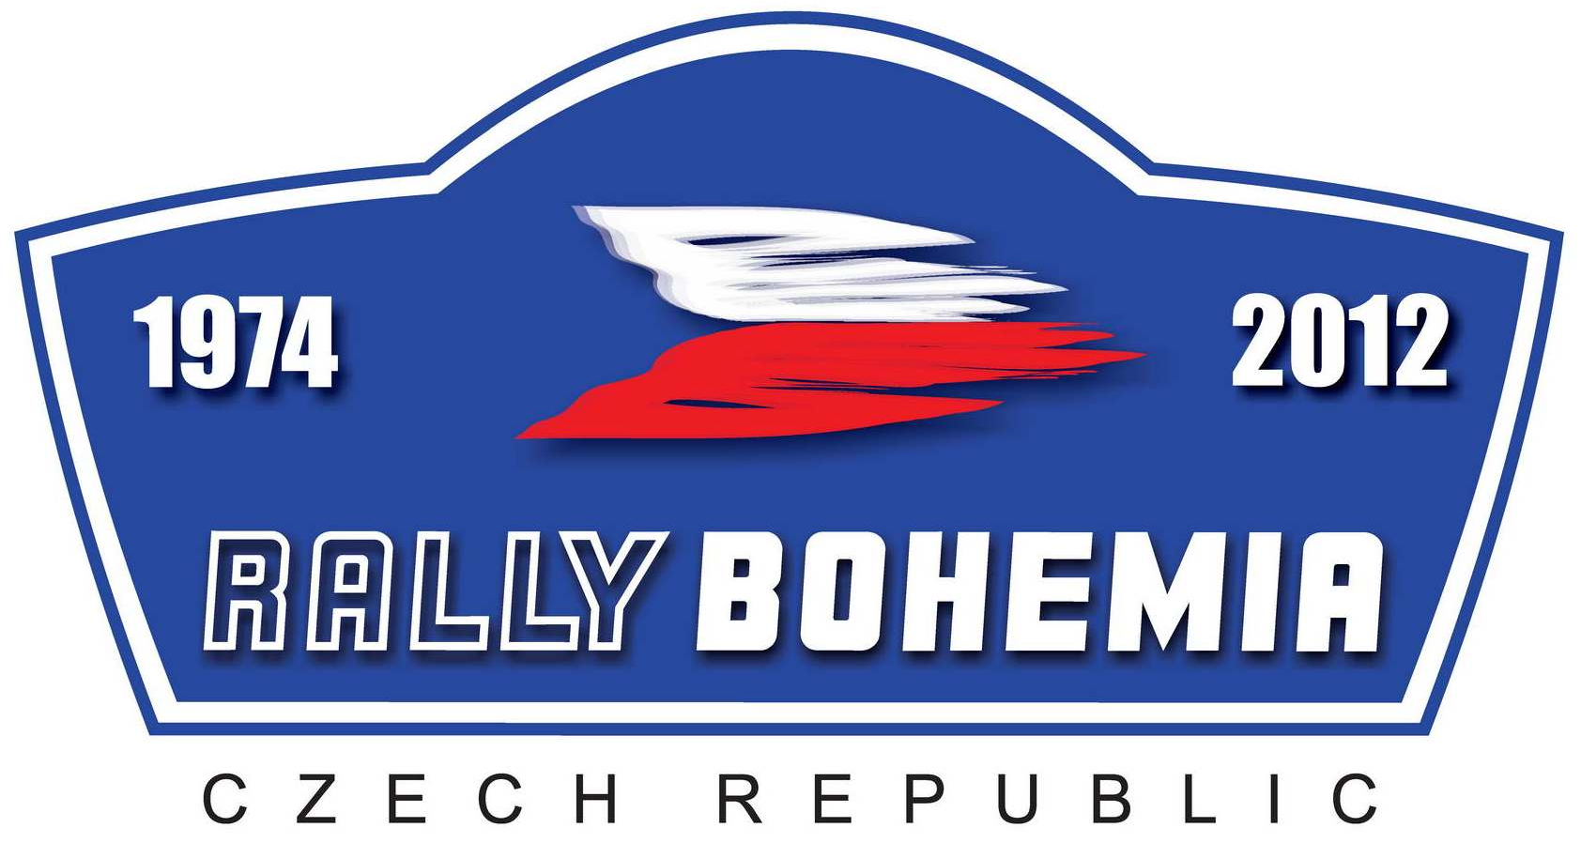



Autoklub Bohemia Sport v AČR, Sosnová 200, 470 01 Česká Lípa
Tel: +420 487 824745, Fax: +420 487 521789, e-mail: info@rallybohemia.cz, www.rallybohemia.cz

Entry Form Rally Bohemia Historic Show

 | First driver | Co-driver
Family name
First (given) Name
Date of birth
Nationality (as passport)
Postal address
Address for correspondence (1 or 2) | 1. | 2.
Telephone
Mobile Tel. No.
E-mail
Driving licence No.
Country of issue
Competitions licence No.
Issuing ASN

Detail of the car
Make |  | Registration No.
Model |  | Country of registration
Year of manufacture |  | Tech. Passport No.
Year of construction if car is replica |  | Cubature cm3
Homologation No. |  | Engine No.
Group / Class on Year of manufacture or conform year  (Eg. 1,2..4, A, B… ) |  | Predominant colour
Historic model or historic origin
Interest information about car

Competitors are asked about photo this car according Article 4.1. SR

Information about drivers

Declaration of Indemnity

My participation on this rally is at my own risk and I will not hold the Organisers responsible for any accidents, injuries, etc. during rally. I declare to have full knowledge of Supplementary Regulations Rally Bohemia Historic Show in compliance with the rally will be run and I guarantee to respect them, without exception.

Every driver and co-driver, incl. the team members are obliged to make his/her own personal accident insurance and to submit it on administrative check if required by the organiser. Every foreign driver and co-driver, incl. the team members are obliged to pay for a medical insurance to cover their costs in case of their treatment in medical installations with in the Czech Republic territory.

Acknowledgement and agreement

By my signature I declare that all information contained on the entry form is correct and that I acknowledge and agree in full to the terms and conditions of the above indemnity and that I accept all the terms and conditions relating to my participation in this event.

Signature of 1st Driver |  | Signature of Co-Driver

Date:

This Entry form can also be sent via email to info@rallybohemia.cz. However the crews are asked to sign it after arrival.

